COLOR TEST

Colors associated with a emotions

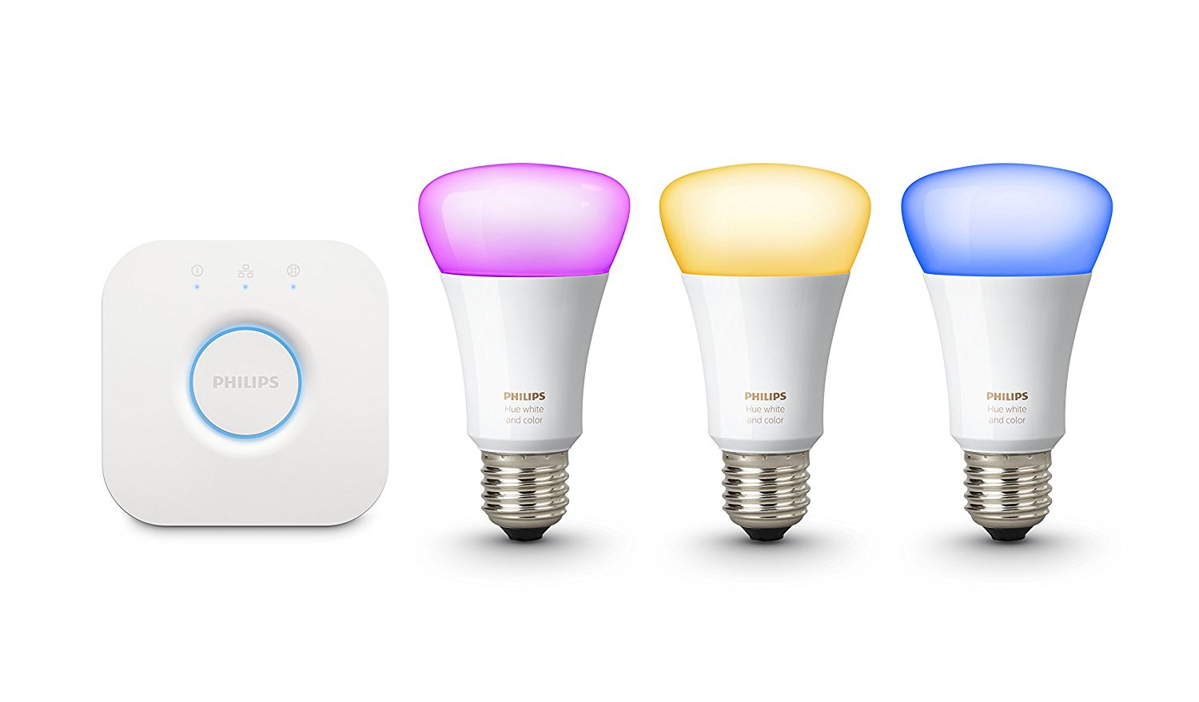

**Anders & Bart**

8-6-2018

GROUP 1 - PROFTAAK OCÉ

# 

# INTRODUCTION

After the first test, where we tested the attention of the people, we need another test before we can fully integrate the Philips Hue lights into our project. We want to verify the research about the emotion of color. To do this, we will show the test person different colors, and ask him/her to assign the colors to one of the following category: Normal, warning and error. When the person doubts, we can ask some questions about the emotion they are feeling when they see the color.

The hypothesis of this test is based on the test outcome we expect, after looking at the results of the research.

# RESEARCH

The research we have done so far states that certain colors is associated with different emotions/actions. The perception of certain colors is documented and corporations use colors to manipulate with their customers. For example: In food stores, bread is normally sold in packaging decorated or tinted with golden or brown tones to promote the idea of home baked and oven freshness.

|  |  |
| --- | --- |
| COLORS COMMONLY USED TO IDENTIFY SEVERAL EMOTIONS | |
| BLACK | MOURNFUL, COLD |
| BLUE | SHYNESS, CALMNESS, SADNESS |
| GREEN | HEALTH, RELIABILITY, SAFETY |
| GREY | EMOTIONLESS, DEPRESSION |
| PINK | LOVE, EMBARRASSED, CHERRY |
| RED | ANGER, EMBARRASSMENT, PASSION, LUST |
| WHITE | SHOCKED, SCARED, SICK, MOURNFUL |
| YELLOW | HAPPINESS, CAUTION, COWARDICE |

RESEARCH QUESTIONS

In which category are the colors we are going to show to the test person?

Which emotions are evoked when seeing the colors?

# HYPOTHESIS

The outcome of this test will confirm the research done already.

# EQUIPMENT

1. Philips Hue bulb, Bridge and Router.
2. Computer to document answers.

# PROCEDURE

1. Test person enter the room and, sits down at the table. Testers will explain the test to the test person.
2. Tester 1 will show a color on the philips hue.
3. Test person will determine which kind of alert/event (error, normal/all good, warning) he/she thinks of.
4. Tester 2 will document test persons answer.
5. This process will loop until test person have been shown all colors scheduled.

# DATA RESULTS

|  |  |  |  |  |
| --- | --- | --- | --- | --- |
| TEST PERSON 1 | | | | |
| COLOR | OK | WARNING | ERROR | COMMENT |
| RED |  |  |  |  |
| ORANGE |  |  |  |  |
| YELLOW |  |  |  | IS NOT NOTICEABLE ENOUGH |
| GREEN |  |  |  | NOT REALLY GREEN, A BIT BLEND |

|  |  |  |  |  |
| --- | --- | --- | --- | --- |
| TEST PERSON 2 | | | | |
| COLOR | OK | WARNING | ERROR | COMMENT |
| RED |  |  |  | SOFT COLOR, MORE LOOKING LIKE ORANGE |
| ORANGE |  |  |  | SHOULD BE MORE ORANGE TO BE A WARNING |
| YELLOW |  |  |  |  |
| GREEN |  |  |  |  |

|  |  |  |  |  |
| --- | --- | --- | --- | --- |
| TEST PERSON 3 | | | | |
| COLOR | OK | WARNING | ERROR | COMMENT |
| RED |  |  |  |  |
| ORANGE |  |  |  | NOT AS STRIKING AS RED |
| YELLOW |  |  |  | MILDER THAN ORANGE, LESS URGENT |
| GREEN |  |  |  |  |

|  |  |  |  |  |
| --- | --- | --- | --- | --- |
| TEST PERSON 4 | | | | |
| COLOR | OK | WARNING | ERROR | COMMENT |
| RED |  |  |  |  |
| ORANGE |  |  |  | SMALL ERROR |
| YELLOW |  |  |  |  |
| GREEN |  |  |  |  |

# 

# CONCLUSION

The test results are very expected. The red color is placed in the error category every time, orange is mostly seen as a warning. Yellow is always placed in the warning category. Green is generally known as the color for OK-status.

These results are fully backed by the research done by the group.

# RECOMMENDATION

Since the test confirmed our research, we will make use of the colors, as mentioned in the conclusion, in our prototype.

The colors the bulb produces can be too vague. It can be difficult to distinguish between the different colors, because the bulbs doesn’t show the colors intensively enough. Canon Ocè should consider using another solution.

# SOURCES

1. <https://docs.google.com/document/d/1PW6n5cJ96T1prCvi5pzkLGTmK-nL90JEekFjHhn23tA/edit#> - Eye Section